**A PRELIMENERY REPORT ON**

**AUTOMATIC ACCIDENT DETECTION USING MACHINE LEARNING**

SUBMITTED TO THE SAVITRIBAI PHULE PUNE UNIVERSITY, PUNE

IN THE PARTIAL FULFILLMENT OF THE REQUIREMENTS

FOR THE AWARD OF THE DEGREE

OF

**BACHELOR OF ENGINEERING (COMPUTER ENGINEERING)**

##### SUBMITTED BY

**SURAJ PUNDLIK BHUJBAL** **(B223009)**

**MANISH KAILAS GAIKWAD** **(B211017)**

**YASH RAJARAM NAGARE** **(B211049)**



## **DEPARTMENT OF COMPUTER ENGINEERING**

## **NARHE, PUNE – 411041**

## **SAVITRIBAI PHULE PUNE UNIVERSITY**

## **2021 -2022**



**CERTIFICATE**

This is to certify that the project report entitles

**“AUTOMATIC ACCIDENT DETECTION USING MACHINE LEARNING”**

Submitted by

**SURAJ PUNDLIK BHUJBAL** **(B223009)**

**MANISH KAILAS GAIKWAD** **(B211017)**

**YASH RAJARAM NAGARE** **(B211049)**

is a Bonafide student of this institute and the work has been carried out by him/her under the supervision of **Prof. Afsa Manjyar** and it is approved for the partial fulfillment of the requirement of Savitribai Phule Pune University, for the award of the degree of **Bachelor of Engineering** (Computer Engineering).

**(Prof. Afsa Manjyar)** **(Prof. A. V. Mote)**

Guide Head

Department of Computer Engineering Department of Computer Engineering

**(Prof. ________________)**  **(Dr. Ajit M. Kate)**

External Examiner Principal,

SPPU Zeal College of Engineering & Research, Pune-41

Place : Pune

Date :

**ACKNOWLEDGEMENT**

We are highly indebted to our guide **Prof. Asha Manjyar** for their guidance and constant supervision as well as for providing necessary information regarding the report and also for their support in completing the project report. We would like to express our special gratitude and thanks to the Staff Members of the Department of Computer Engineering for giving us such attention and time. This acknowledgement would be incomplete without expressing my thanks to **Prof. A. V. Mote** Head of the Department (Computer Engineering) for her support during the work. We would like to extend our heartfelt gratitude to the Principal, **Dr. Ajit M. Kate** who provided a lot of valuable support, mostly being behind the veils of college bureaucracy. We would also like to express our gratitude towards our parents and friends for their kind cooperation and encouragement which help me in completion of this report. Our thanks and appreciations also go to our colleague in developing the project report and people who have willingly helped us out with their abilities.

**ABSTRACT**

Drowsiness is one of the underlying causes of driving accidents, which contribute to many road fatalities annually. The number of fatal and disabling road accidents are increasing day by day and is a real public health challenge. Many times, in the road accidents, human lives will be lost due to delayed medical assistance. Drowsiness is one of the underlying causes of driving accidents, which contribute to many road fatalities annually. This paper focuses on designing web application-based accident detection system and avoidance system which detect accidents using image processing and inform the location of accident using text SMS.

Now-a-days accidents happen frequently, due to poor emergency facilities there are loss of human lives. The proposed system provides a solution to this drawback. An accelerometer sensor monitors the acceleration of the vehicle. A threshold value is fixed. If there is any change in vehicle’s tilt position, orientation and if it is acceleration value is above the threshold value. Immediately it sends signal to the microcontroller. An API module is activated and it sends the pre-stored message to the emergency contacts such as relatives, hospitals, police station.

**LIST OF FIGURES**

|  |  |  |
| --- | --- | --- |
| **Sr.No.** | **Figure Name** | **Page No.** |
| 5.1 | System Design |  |
| 5.2 | CNN Training Data Flow Diagram |  |
| 5.3 | Flow Chart |  |
| 7.1 | Output of CNN Training |  |

**LIST OF TABLES**

|  |  |  |
| --- | --- | --- |
| **Sr.No.** | **Figure Name** | **Page No.** |
| 2.1 | Literature Survey |  |

**TABLE OF CONTENTS**

**Chapter** **Title Page No.**

**1** **Introduction**

1.1 Motivation

1.2 Problem Definition

**2** **Literature Survey**

**3** **Software Requirements and Specification**

3.1 Introduction

3.2 Existing System

3.3 Software Requirements

3.4 Hardware Requirements

3.5 Technologies Used

**4** **System Implementation Plan**

4.1 Project Implementation Steps

4.2 CNN Training Implementation Steps

**5** **System Design**

5.1 System Architecture

5.2 Data flow diagram

5.3 Flow Chart

**6** **Other Specification**

**7** **Result, Conclusion & Future Works**

**8** **References**

**Chapter 1**

**INTRODUCTION**

In the 21th century, the number of vehicles exponentially increases due to growth in the automobile industry. As the number of vehicles increases, the accident also increases. The reason of most of the road accidents are heterogeneous traffic and lack of traffic separation. According to World Health Organization (WHO), India is the leading country in the road accident deaths. In India, 13 million peoples were dead in road accident in the year of 2014-15. These statistics are reported accidental records but there are numbers of accident, which are unreported. Hence, the numbers of actual accident are more than the statistic of World Health Organization (WHO).

Drowsiness and drunk drivers are one of the underlying causes of driving accidents, which contribute, to many road fatalities annually. Although numerous methods have been developed to detect the level of drowsiness, techniques based on image processing are quicker and more accurate in comparison with the other methods. We propose system to detect drowsiness using image processing, which will avoid accidents. We also detect accident and will send SMS alert in case of accident. Every day more than 500 people die every day due to road accidents. The main cause of accidents is drunk driver and drowsy driver. If we provide timely service to accidental vehicle, we can save some lives. This system is web application-based accident detection and avoidance system which detects an accident using image processing and inform the location of accident via text SMS.

Drowsiness and drunk drivers are one of the underlying causes of driving accidents, which contribute, to many road fatalities annually. Although numerous methods have been developed to detect the level of drowsiness, techniques based on image processing are quicker and more accurate in comparison with the other methods. We propose system to detect drowsiness using image processing, which will avoid accidents. We also detect accident and will send SMS alert in case of Accident detection using machine learning

**1.1 MOTIVATION**

Accidents have been a major cause of deaths in India. More than 80% of accident-related deaths occur not due to the accident itself but the lack of timely help reaching the accident victims. In highways where the traffic is really light and fast-paced an accident victim could be left unattended for a long time. The intent is to create a system which would detect an accident based on the live feed of video from a CCTV camera installed on a highway. The idea is to take each frame of a video and run it through a deep learning convolution neural network model which has been trained to classify frames of a video into accident or non-accident. Convolutional Neural Networks has proven to be a fast and accurate approach to classify images. CNN based image classifiers have given accuracy's of more than 95% for comparatively smaller datasets and require less preprocessing as compared to other image classifying algorithms

**1.2 PROBLEM DEFINITION**

To design the system which detects an accident using image processing and send SMS text to nearby hospital and police station.

**Chapter 2**

**LITERATURE SURVEY**

|  |  |  |  |
| --- | --- | --- | --- |
| **Title of Paper** | **Author** | **Publisher** | **Published on** |
| A Deep Learning based Accident Detection System | Gokul Rajesh, Amitha Rossy Benny, Harikrishnan A, James Jacob Abraham and Nithin Prince John | IEEE | 2020 |
| Accident Detection using Convolutional Neural Networks | Sreyan Ghosh, Sherwin Joseph Sunny, Rohan Roney | IEEE | 2019 |
| Convolutional Neural Network Based Image Processing System | Hankil Kim, Jinyoung Kim, and Heakyung Jung | JICCE | 2018 |

Table 2.1: Literature Survey

**Chapter 3**

**SOFTWARE REQUIREMENTS AND SPECIFICATION**

**3.1 INTRODUCTION**

**CONVOLUTIONAL NEURAL NETWORK**

* Convolutional Neural Network is a machine learning algorithm used for the image classification problems.
* It is a binary classification algorithm used when the target variable is dichotomous (0 or 1).
* It measures the relationship between dependent and independent variables.
* The variables must follow a binomial distribution.
* The dependent variables should have mutually exclusive and exhaustive categories.
* It is a predictive analysis algorithm which uses probability for prediction.
* It uses a pooling and an activation function for feature extraction of an output layer.
* There will be a brief breaking down of the flattening process and how to move from pooled to flattened layers.
* In a fully connected layer, every neuron from input layer should be connected to every other layer in the hidden layer.
* The output layer after pooling, feature extraction gives non-linearity which labels the image as 0 or 1.

**3.2 EXISTING SYSTEMS**

Many times, in the road accidents, human lives will be lost due to delayed medical assistance. The existing system was not able to provide the SMS alerts along with location of accident hence road accident deaths are more prominent.

**3.3 SOFTWARE REQURENMENTS**

1. Python 3.8

2. Embedded C

**Packages**

1. Flask

2. OpenCV

**3.4 HARDWARE REQURENMENTS**

1. Windows PC with 4GB Ram 128GB HDD/SSD

**3.5 TECHNOLOGIES USED**

**Front End**

1.HTML

2.CSS

**Back End**

1.Python

2.Jinja templates

**Chapter 4**

**SYSTEM IMPLEMENTATION PLAN**

* Dataset
* Kaggle: Dataset Hosting Website [Accident Detection Dataset]

-Two folders training set and testing set. Training set used to train module &Testing set is used to evaluate the module. In case of training set we have 70% images and in case of testing set we have 30%images.

* Front End: HTML, CSS
* Backend: Python, Jinja Templates
* Framework: Flask
* Algorithms: CNN

**4.1 PROJECT IMPLEMENTAION STEPS**

1. Training Accident Detection Dataset Using CNN: Trained the data using convolutional neural network.
2. Testing Accident Detection Dataset Using CNN: Testing system using testing data set
3. Testing SMS API: SMS alert will send on mobile in case accident detect.
4. Linking Front end & Backend.

**4.2 CNN TRAINING IMPLEMENTAION STEPS**

1. Loading the packages
2. Building the CNN model
3. Feature extraction
4. Classification layer
5. Budling the CNN model
6. Image Augmentation
7. Loading the dataset
8. Training the CNN model
9. Saving the Model
10. Plotting the performance

**Chapter 5**

**SYSTEM DESIGN**

**5.1 SYSTEM ARCHITECTURE**

Figure 5.1: System Architecture

**Description**

Convolutional Neural Networks (CNN) are typically used to analyze image data and map images to output variables. However, we decided to build a 1-D CNN and send in numerical features as sequential input data to try and understand the spatial relationship between each feature for the two states. Our CNN model has 5 layers including 1 convolutional layer, 1 flatten later, 2 fully connected dense layers, and 1 dropout layer before the output layer. The flatten layer flattens the output from the convolutional layer and makes it linear before passing it into the first dense layer. The dropout layer randomly drops 20% of the output nodes from the second dense layer in order to prevent our model from overfitting to the training data. The final dense layer has a single output node that outputs 0 for alert and 1 for drowsy.

Image capturing is done in real time online mode. Webcams mounted on the monitor screens, inbuilt laptop webcams and front camera of mobile phones will be used for the purpose. A real blink of an eye takes 300 to 400 milliseconds. Since there're 1000 milliseconds in each second, a blink of an eye takes around one-third of a second. Though it seems like a short period, considering the span of a single second it is significant enough. The standard webcams and front cameras usually have recording rates of 30fps with some going up to 120fps to 240fps. For this system, a capturing device of 30fps is well suited.

**5.2 DATA FLOW DIAGRAM**

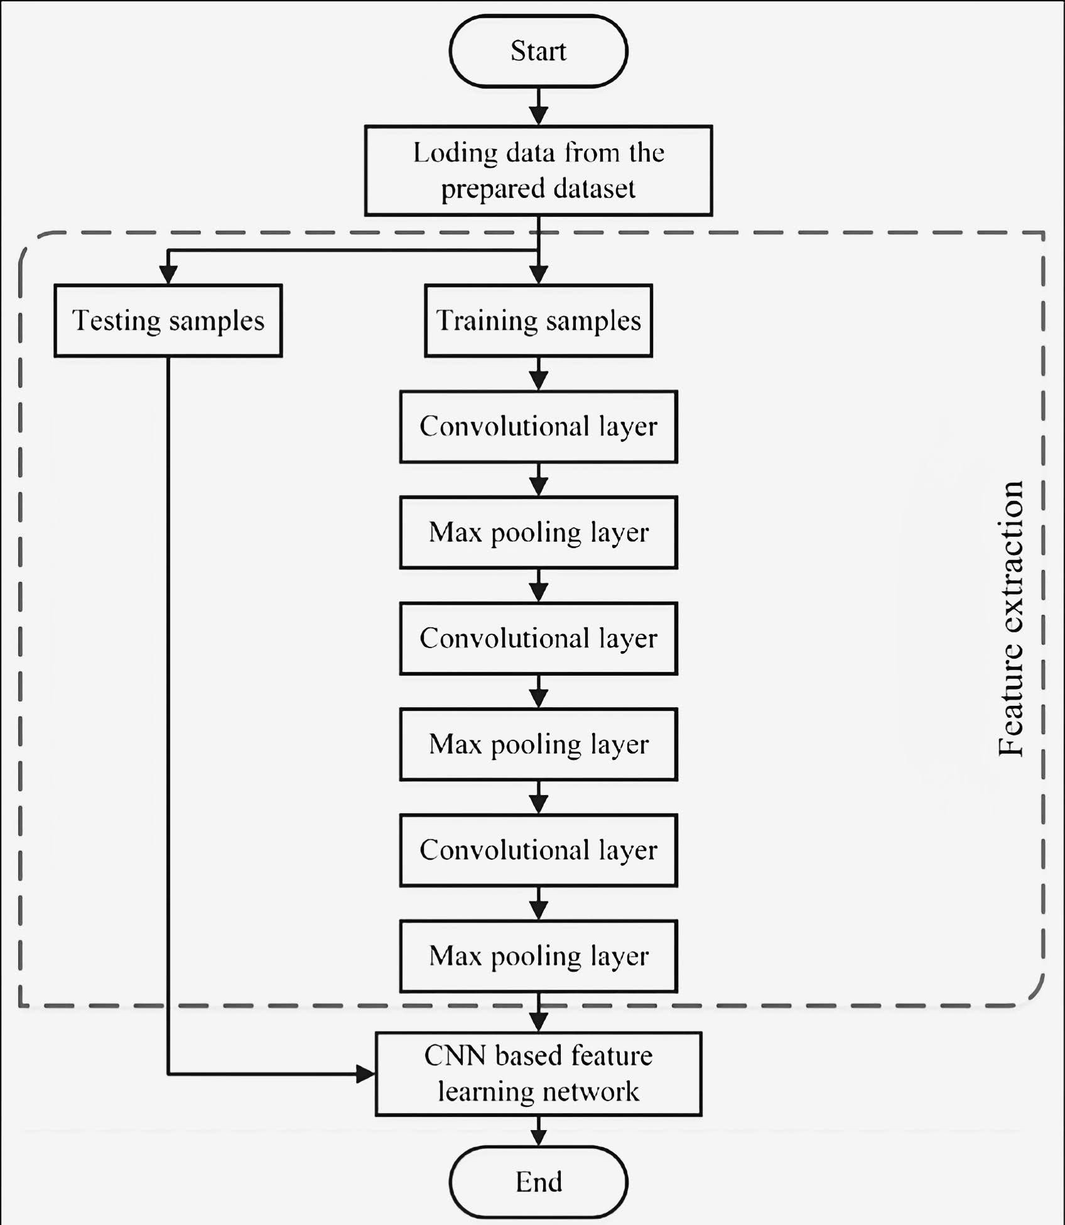

Figure 5.2: CNN Training Data Flow Diagram

* **Convolutional Layer**

The convolution layer is the core building block of the CNN. It carries the main portion of the network’s computational load.

This layer performs a dot product between two matrices, where one matrix is the set of learnable parameters otherwise known as a kernel, and the other matrix is the restricted portion of the receptive field. The kernel is spatially smaller than an image but is more in-depth. This means that, if the image is composed of three (RGB) channels, the kernel height and width will be spatially small, but the depth extends up to all three channels.

During the forward pass, the kernel slides across the height and width of the image-producing the image representation of that receptive region. This produces a two-dimensional representation of the image known as an activation map that gives the response of the kernel at each spatial position of the image. The sliding size of the kernel is called a stride.

If we have an input of size W x W x D and Dout number of kernels with a spatial size of F with stride S and amount of padding P, then the size of output volume can be determined by the following formula

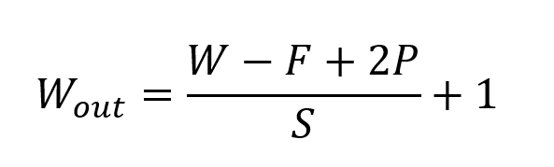

* **Pooling Layer**

The pooling layer replaces the output of the network at certain locations by deriving a summary statistic of the nearby outputs. This helps in reducing the spatial size of the representation, which decreases the required amount of computation and weights. The pooling operation is processed on every slice of the representation individually.

There are several pooling functions such as the average of the rectangular neighborhood, L2 norm of the rectangular neighborhood, and a weighted average based on the distance from the central pixel. However, the most popular process is max pooling, which reports the maximum output from the neighborhood.

If we have an activation map of size *W* x *W* x *D*, a pooling kernel of spatial size *F*, and stride *S*, then the size of output volume can be determined by the following formula

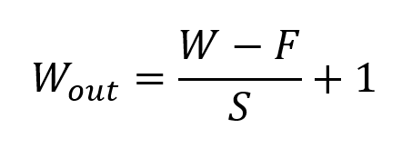

* **Fully Connected Layer**

Neurons in this layer have full connectivity with all neurons in the preceding and succeeding layer as seen in regular FCNN. This is why it can be computed as usual by a matrix multiplication followed by a bias effect.

The Fully Connected layer helps to map the representation between the input and the output.

**5.3 FLOW CHART**

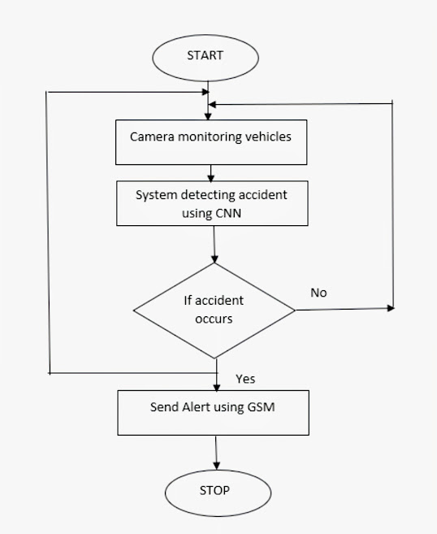

Figure 5.3: Flow Chart

**Chapter 6**

**OTHER SPECIFICATION**

* **Advantages**

1. Sophisticated security.
2. Monitors hazards and threats.
3. Alert message to nearby Hospitals & Police station.
4. The immediate medication will be provided to the accident victims in remote area.
5. Easy to operate.

* **Disadvantages**

1. Doesn’t support offline function

**Chapter 7**

**RESULT & CONCLUSION**

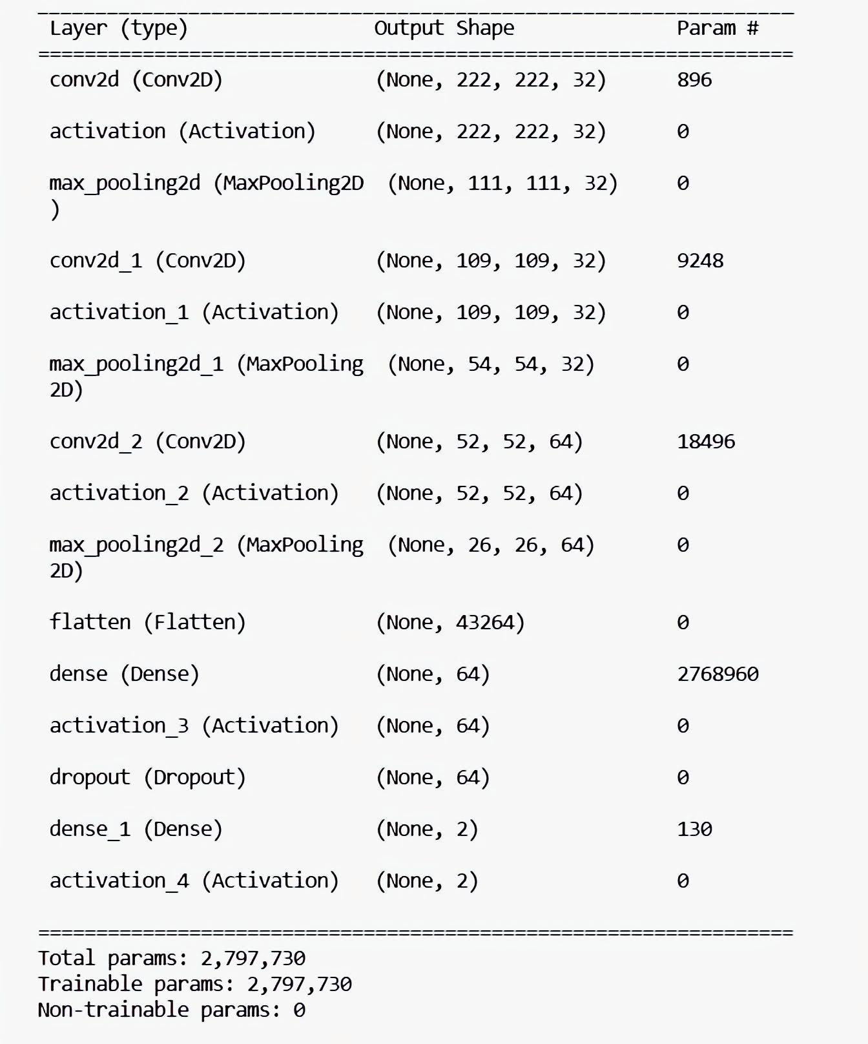

Figure 7.1: Output of CNN training

**RESULT**

After the training, the system was able to detect accident images and non-accident images.

**CONCLUSION**

The proposed system is used to detect road accidents. When an accident is detected, an alert message is sent to nearby control rooms using the API module. This system is more reliable and economical when compared to existing systems. It can detect accidents with high level of accuracy as the model architecture is trained using the created dataset. Our preliminary evaluation shows that the system works in a perfect manner and can be deployed over a large area. With the help of this system, immediate action can be taken by sending alert to the officials and will help the medical teams to reach the accident spot in time and save the valuable human lives. Thus, the proposed system will play an important role in the society where road accidents have nowadays become a major threat.

**FUTURE WORK**

Our next step is to perform the testing part and test maximum number of images from testing dataset. And we will make assure that there would be no bugs in our project After testing part only GUI part will be remaining, that part also we will complete as soon as possible.

**Chapter 8**

**REFERENCES**

[1] Gokul Rajesh, Amitha Rossy Benny, Harikrishnan A, James Jacob Abraham and Nithin Prince John “A Deep Learning based Accident Detection System” IEEE 2020

[2] Sreyan Ghosh, Sherwin Joseph Sunny, Rohan Roney “Accident Detection using Convolutional Neural Networks” IEEE 2019

[3] Hankil Kim, Jinyoung Kim, and Heakyung Jung “Convolutional Neural Network Based Image Processing System” JICCE 2018